If any of us profit from these ideas, we split it 50+50.

Consider old technologies that you can replace.

# Fridges!

## Individually packaged cooling!

Biodegradable material and thermal insulator! - Sasha

# Doors

## Selective barrier

Retractable crystal that is opaque, rigid, and thermally insulating.

Cheaper than wood.

# Texting, Writing, and Speaking

## Measure the electric current from muscle movements to

## type text and select/generate images

### Already used for Stephen Hawking (with eye muscles).

### Receive messages from something tactile (or just a visual display like an app)

# Bathroom

## Shower Heads

Shower heads on the walls of the shower

I think rich people might buy it. - Marcos

# Weight Efficient Long Term Thermonuclear

Order of magnitude a comprehensive plan for nuclear, then ask someone in the field for specifics.

## Things to Investigate

### Shielding

Current plan for shielding: 1mm of water sandwiched by 1micron plates of lead on each side.

How do the fungi (radiotrophic) around Chernobyl attenuate radiation? Much more promising!!! [doi.org/10.1101/2020.07.16.205534](http://doi.org/10.1101/2020.07.16.205534)

### Bottlenecks: Any constraints in time, availability, or cost that hinder these facilities and/or batteries

#### Radionuclide Availability

### Energy Surplus Prevention

Reduce the flux of energy to the thermocouple?

The easiest way to do this is retractable and expandable shielding

and/or rotating an asymmetric/nonuniform thermocouple?

Are there cheap widely available thermocouples with easily (in real time) adjustable efficiencies?

### Simple automated Way to Find the Ideal Nuclides

Script in (a) Colaboratory cell(s) that quantifies the merits of each

isotope (in no particular order yet): availability, cost, time to produce and acquire, and proximity of half-life to a century.

Ideally this would be a very general set of functions and/or classes to evaluate isotopes and an automated (or just fast/low effort) way to acquire relevant data.

First, determine which decay paths are most promising (the ones that need the least shielding?)

### Brief Outline and Description of Supply Chain and Implementation

### Inclusive and Welcome Campaign to Increase the Public Acceptance and Support of Nuclear Power

## Practical Domestic RTGs

## (Encased in lead) encased in water?

### Why can’t it be miniaturized?

Thermoelectric conduit attached to a small rod of plutonium/uranium.

Is there something sufficiently hot/radioactive that is not

Fissile?

<https://doi.org/10.1016/j.rser.2019.109572>

[doi.org/10.1109/ICT.1999.843442](https://doi.org/10.1109/ICT.1999.843442)

### 

## Rough Estimate of Energy Production:

<https://github.com/MarcosP7635/Nuclear>

Energy production exponentially decays :(

### U238 Production

Can you melt and centrifuge out uranium from minerals?

## Electrothermal Conduit

[Thermocouples](https://en.wikipedia.org/wiki/Thermocouple)!

Nuclear isotopes as energy storage?

<https://doi.org/10.1016/j.mtener.2021.100688>

## [Half-life vs. Power Output](https://github.com/MarcosP7635/Nuclear/blob/main/Energy.ipynb) [Colaboratory](https://colab.research.google.com/drive/1y54_4hrcDjCrpFGT0sU7W5sPNH-JiJTR?usp=sharing)

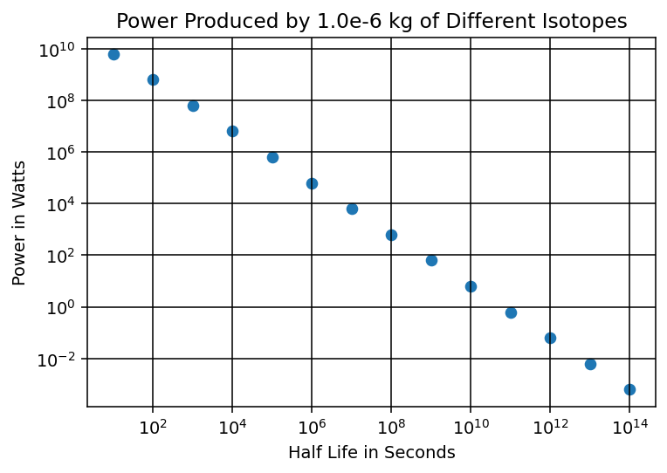

## Potential Applications

A smartphone needs on the order of 20 W, so assuming we need the isotope to produce on the order of 10^1.9 W/mg = 80W/mg the graph implies this could be powered continuously for 30 years! Could this be used for supercomputers too?

Only 1g needed to produce a kW for a century. Surely a hospital would benefit from this?

It doesn’t even need to be fissile!!

There are around 10^4.5 hospitals in the US and they each consume [~5% of the total US energy supply](http://large.stanford.edu/courses/2017/ph240/xiao-s2/) which is has grown by [~1000x since 2007](https://www.eia.gov/outlooks/aeo/pdf/00%20AEO2021%20Chart%20Library.pdf) which was then [estimated to be 10^17 J cumulatively in the US.](http://large.stanford.edu/courses/2017/ph240/xiao-s2/) Thus we have 17-1.5 = 16.5.

Thus a hospital in the US needs 10^16.5 J. This seems wrong. Revise later.

Revising ->

[The US uses around 1.3 kW/person](https://www.eia.gov/international/data/world/electricity/electricity-consumption?pd=2&p=0000002&u=0&f=A&v=mapbubble&a=-&i=none&vo=value&t=C&g=00000000000000000000000000000000000000000000000001&l=249-ruvvvvvfvtvnvv1vrvvvvfvvvvvvfvvvou20evvvvvvvvvvnvvvs0008&s=315532800000&e=1546300800000&)

(Handy conversion- 1Btu ~ 10^-3.5 kWH)

Thus, according to <https://www.eia.gov/international/rankings/world?pa=12&u=0&f=A&v=none&y=01%2F01%2F2019>, the US uses .03 quadrillion Btu = 30 trillion kWH. Assuming hospitals use on the order of ~5% of the US energy supply we jave 1.5 trillion kWH used by US hospitals in 2019. Assuming there are 10^4.5 hospitals we have 2*10^7 kWH consumed by the average US hospital in 2019.

Thus, each hospital each year needs about 2*10^15 J. This is nearly one order of magnitude off from the sketchy estimate before revising. If 1mg of a 100-y half life isotope can provide 1W for a century, then (by the revises estimate of annual power consumption), on average in 2019 a US hospital needed 2*10^7.5 W. Thus, each hospital would need ~10^8 mg or 100 kg to be powered autonomously without interruption for a century. The entire US's energy needs (at the 2019 rate of consumption) for the next century would only need 10^8 kg.

## Radionuclide Availability

Old paper <https://www.ncbi.nlm.nih.gov/books/NBK11468/#a200130bcddd00075>

### Cheap radioactive minerals?

Is there a cheap fast way to purify uranium containing minerals?

## Assumptions to account for

Under what criteria is half-life constant? What decay paths will occur? What shielding is sufficient?